SHUPL System Sign up and Apply Guide

Step1: copy website lbzs.shupl.edu.cn and use your email sign up, remember your password.

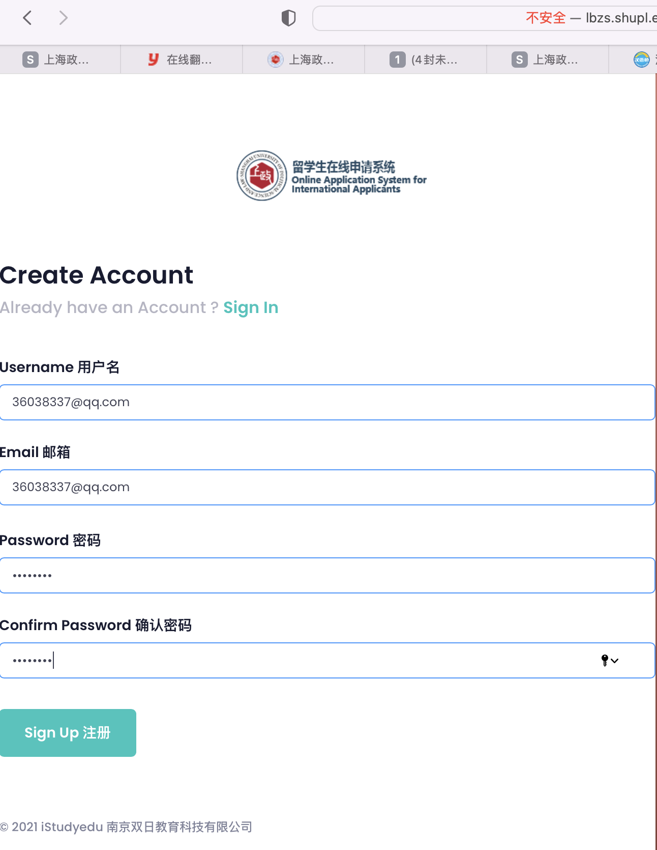

Step2: your email receive a verify mail, and click the blue block.

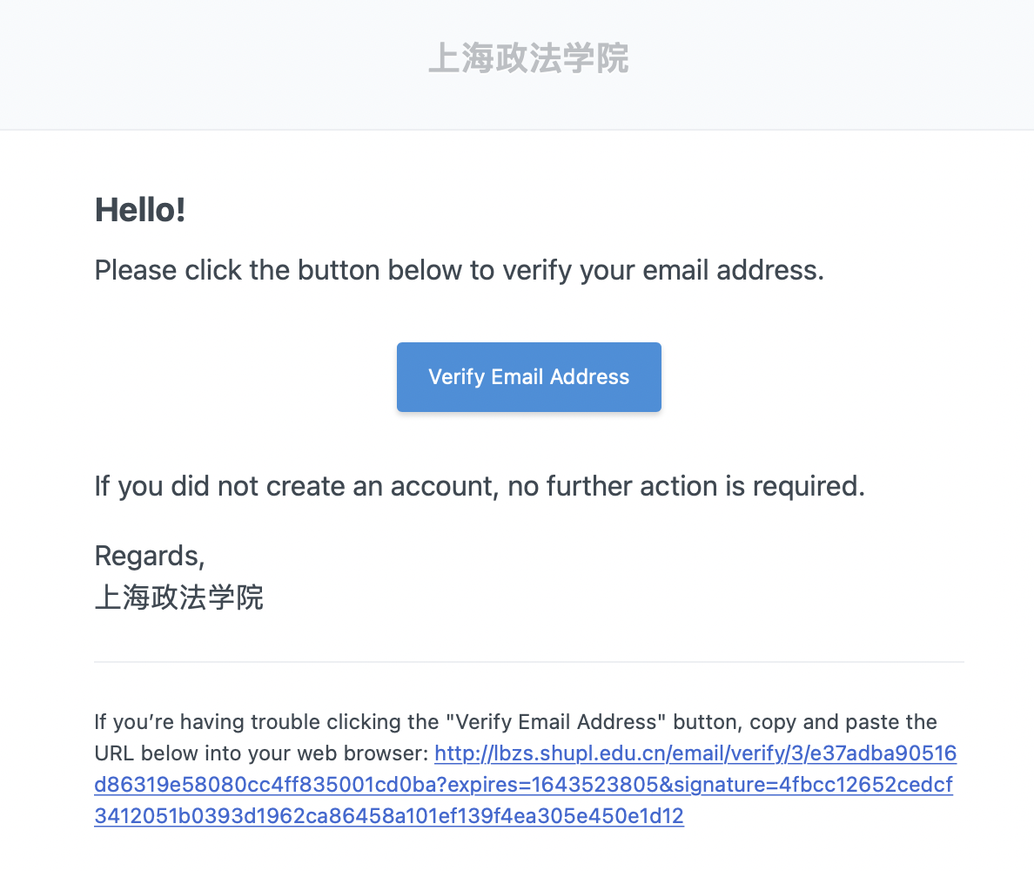

Step3: use your email sign in, log in the system

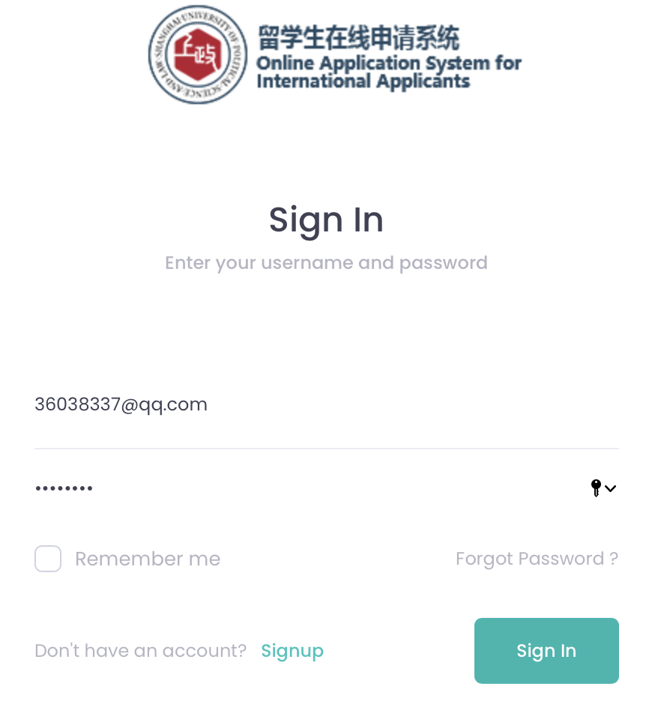

Step4: look the left menu, click “courses”, And Scroll down to the bottom of the page, find “meeting on cloud, entering China now 2022”, and click the right “apply”, fill the form and you will get an application number.

